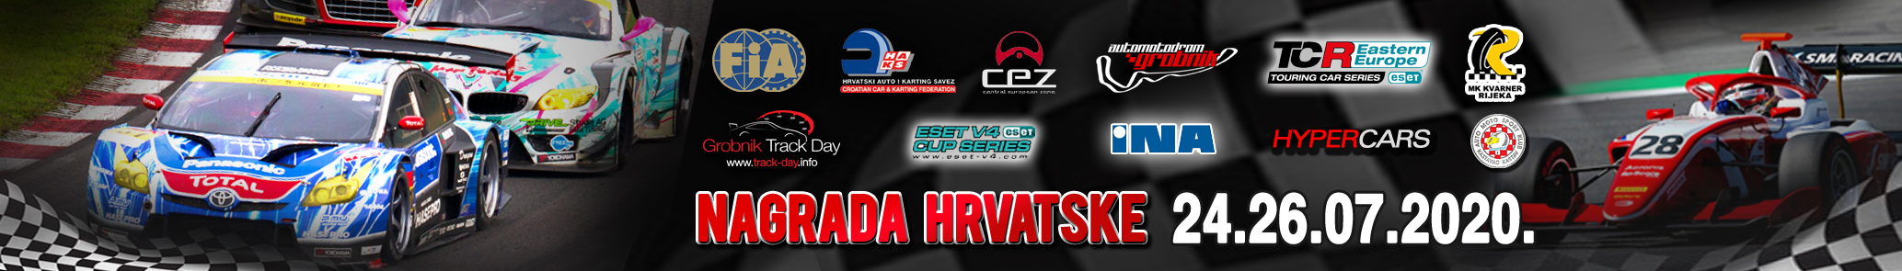

COVID-19 rules and obligations

We look forward to welcoming you again at the Automotodrom Grobnik! In order to ensure the health and safety of everyone involved, the organizer must ensure that the following points are observed:

• Only active and registered participants for the event may be present at the paddock and at the
circuit closed area.

• A maximum of 500 participants are permitted on the site.

• Organiser MUST receive latest Monday 20th July 8 PM: name and surname, home adress,
town, state, mobile phone number of all team members…!!!

• All teams must register participants, ALL TEAM MEMBERS on the link:
https://docs.google.com/forms/d/e/1FAIpQLScagh3KY6-0DH73rhhN3j7RZeQw7_n9hkpLiX3i1MhK8KIHnA/viewform
On the administrative check driver will receive passes only for registred team members. Passes
must be visible all the time in the paddock. Team members without pass will not be alowed to be
present on the circuit!

• All drivers must sent scan of DRIVERS LICENCE AND STARTING PERMISSION. Organiser MUST
receive it latest Monday 20th July untill 8 PM on the email: cezgrobnik@gmail.com

• spectators will not be alowed at the paddock and on the circuit

• The minimum distance of 1 meter must be observed across the entire paddock open area.

• The minimum distance of 2 meters must be observed across the entire paddock closed areas and
inside of the buldings.

• An MNS mask (mouth and nose protection) must be worn across the entire paddock closed areas
and inside of the buldings. MNS masks are to be brought by the participants themselves, but can be
purchased from the management if required.

• Disinfectants are available in the sanitary areas.

• In the paddock, a generous distribution of parking spaces must be ensured, if possible guarantee
maximum safety distances.

• As far as possible, pit doors (gates) should be kept open.

• Registrations, driver meetings and vehicle inspections etc. should, if possible, be dealt with in
advance or electronically.

• All communication between the organizer and the participants on the site should be contactless as
much as possible.

• When forming groups, the minimum distance of 1 meter is mandatory at entire paddock open area.

• All participants must be informed by the organizer of these guidelines in advance of arriving at the
site. Signs with information on distance and hygiene measures are located at each entrance.

• There will not be organised drivers meeting. All the details drivers will receive via email or on the
administrative check

All this rules and obligations are subject to change at short time. All drivers and teams MUST RESPECT this rules and obligations…!!!

PROTECT YOUR SELF, PROTECT YOUR TEAM MEMBERS, PROTECT THE MATSHALS

